What time is it? Worksheet 1

Complete the clock hands:
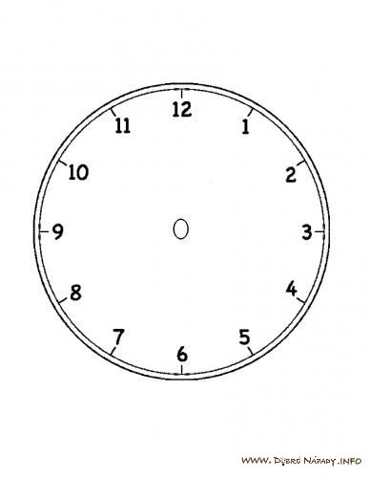
It´s five o´clock. It´s quarter past eight. It´s quarter to four.
It´s half past two. It´s half past eleven. It´s quarter past ten.

