Worksheet 2
Task1:

Divide (cut) the pizza according to the number of children in your group. All pieces must be equally large. 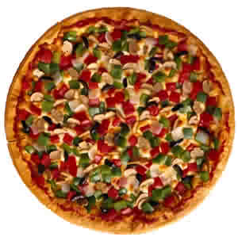
Task2:

Answer the questions:
- How many pieces of the pizza have you got in your group?
- How big are the pieces of the pizza in your group? Write down the
fraction .

