UNIT 1: Exploring diversity

Acivity 1.1: THE PLACE WHERE WE LIVE

Worksheet 1.1.1
- 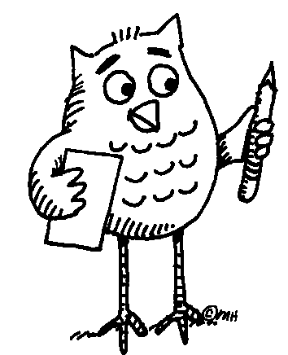 In what language is the title?
- Can you match the text with the name of the language?

RUSSIAN, CZECH, GERMAN, ITALIAN, SLOVAK, VIETNAMESE, ENGLISH, FRENCH, SPANISH, POLISH, SWEDISH
The place where we live.
L´endroit où nous habitons.
Место, где мы живём
Stället där vi bor.
Chỗ sống của chúng tôi
Místo, kde žijeme.
Miesto, kde žijeme.
Il luogo dove viviamo.
El lugar donde vivimos.
Der Platz, wo wir leben.
Miejsce, gdzie mieszkam.

3. Can you translate the title into any other language? If so, please, write it down here:
………………………………………………………………………………………………….
………………………………………………………………………………………………….
... Follow up tasks for the whole class:
1. Do you know where these languages are spoken? Show the countries on the map.
2. Can you say the title “The place where we live” in any other language?
3. Can you teach your classmates how to say it? They will repeat after you.

