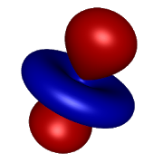 | Hydrogen atom orbitals | https://play.google.com/store/apps/details?id=com.vlvolad.hydrogenatom
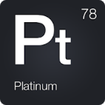 | Periodická Tabulka 2020 - Chemie | https://play.google.com/store/apps/details?id=mendeleev.redlime
 | Merck PTE | https://play.google.com/store/apps/details?id=de.merck.pte
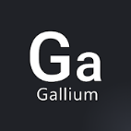 | Periodická Tabulka - Hra | https://play.google.com/store/apps/details?id=august.mendeleev.quiz
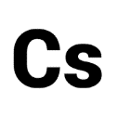 | Chemické Značky Kvíz | https://play.google.com/store/apps/details?id=marijndillen.chemicalsymbolsquiz
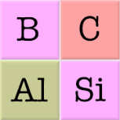 | Chemické prvky a periodická tabulka - Kvíz symbolů | https://play.google.com/store/apps/details?id=com.asmolgam.elements
 | Chemical Reactions | https://play.google.com/store/apps/details?id=com.lahodiuk.inorganicchemistryreactions
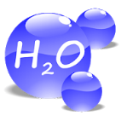 | Chemistry Advisor | https://play.google.com/store/apps/details?id=com.chemministry.chemadviser
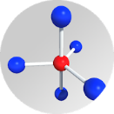 | 3D VSEPR | https://play.google.com/store/apps/details?id=com.enteriosoft.vsepr
 | Molecular 3D | https://play.google.com/store/apps/details?id=com.hkdilan.molecularstructure
 | Molecular Constructor | https://play.google.com/store/apps/details?id=com.alextepl.molconstr
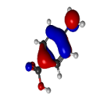 | WebMO | https://play.google.com/store/apps/details?id=net.webmo.android.moledit
 | ModelAR Organic Chemistry | https://play.google.com/store/apps/details?id=com.alchemie.modelset
 | KingDraw Chemical Structure Editor | https://play.google.com/store/apps/details?id=com.kingagroot.kingdraw
 | Alchemie Isomers | https://play.google.com/store/apps/details?id=com.alchemie.isomers
 | Mol Chemistry | https://play.google.com/store/apps/details?id=com.substrategames.mol
 | MEL Chemistry | https://play.google.com/store/apps/details?id=com.melscience.melchemistry
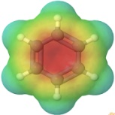 | ChemTube3D | https://play.google.com/store/apps/details?id=www.chemtube3d.com
 | BEAKER - Mix Chemicals | https://play.google.com/store/apps/details?id=air.thix.sciencesense.beaker
 | CHEMIST - Virtual Chem Lab | https://play.google.com/store/apps/details?id=air.thix.sciencesense.chemist
 | SPARKvue | https://play.google.com/store/apps/details?id=com.isbx.pasco.Spark
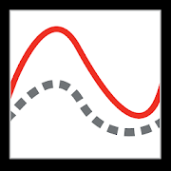 | Graphical Analysis 4 | https://play.google.com/store/apps/details?id=com.vernier.graphicalanalysis

