Saint Nicholas in the Czech Republic
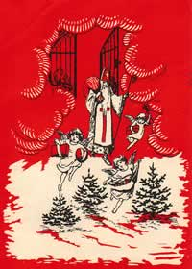
St Nicholas coming down from Heaven ~ Czech Postcard
St Nicholas Center Collection
The most popular of the Advent holidays was—and still is—St. Nicholas Day. It is the only one of the old Czech Advent holidays still celebrated today. It is a special time when children receive sweets and small gifts. They used to be apples, nuts and sweets, while now they are chocolate, toy cars and other small presents. St. Nicholas Day also reminids people that Baby Jesus will soon be here.
Angels lower St. Nicholas, or Svaty Mikuláš,, with a basket of apples, nuts, and candies, down from heaven on a heavy golden cord. On December 5th, the eve of St. Nicholas Day, three figures—kindly St. Nicholas who gives gifts to children, a Devil who comes to take bad children away, and an Angel who pleads on their behalf—form a procession marking the beginning of the Christmas season. The streets are filled with devils rattling chains, St. Nicholases with white cotton beards, long robes and bishops' staffs, and angels with paper wings on their way to visit small children in their homes.
Traditionally, St. Nicholas quizzed children on the prayer-book and the Bible. Today, however, the questions are mostly about the previous year's behavior. The angel writes a record for each child in a large book and the children sing or say a poem to the saint. The devil rattles his chains, threatening to carry bad children off, but the angel, with a gold star on her forehead and dressed in a white gown, protects the children.
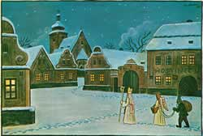
St Nicholas with Angel and Devil
1937 Czech Postcard
St Nicholas Center Collection
Good children receive stockings filled with tangerines, nuts, chocolates, and small gifts. It is said that bad children get old potatoes or coal in theirs. Parents and other relatives also give a St. Nicholas gift, which may be hidden so children must hunt to find it. After the children's treats, St. Nicholas shares a toast with the parents.
In Prague there is a carnival with prizes for the best masks.
A Czech Tradition—brought to the US
St. Nicholas Monuments in the Czech Republic
Rescuing St. Nicholas in the Czech Republic

http://www.stnicholascenter.org/pages/czech-republic/

