ROBIN HOOD
A GOOD HERO OR A BAD HERO?

- In the group, think about who is a hero. Use the mind map.
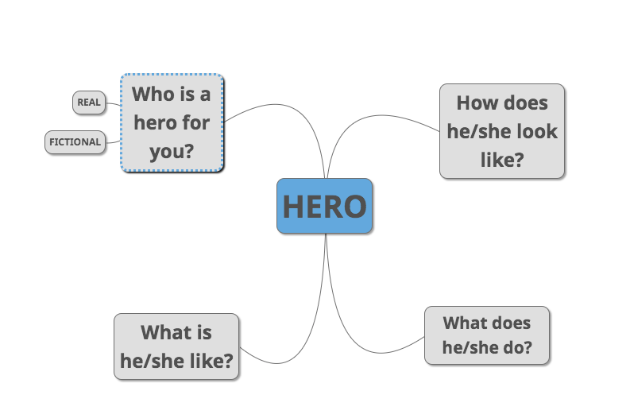
- Listen to the story about Robin Hood.

- Read the text (https://learnenglishkids.britishcouncil.org/short-stories/robin-hood)

- Highlight
Each information about his character yellow (What is he like?)
Each information about what he did blue. For positive action use light blue. For negative action use dark blue.

- Create a T-Graf.

T-Graf

What did Robin do?
positive + negative -

- Think again about Robin. Was he a good hero or a bad hero?
- Find your position in the scale / line in the classroom.

