SURVEY IN OUR CLASSROOM

- Read the questions and make the guess.

Question | Guess | Answer
- How many pupils in the classroom exercise more than 4 hours weekly?
- How many pupils in the classroom read at least 5 hours weekly?

- How many pupils in the classroom study at home more than 10 hours weekly?
- How many pupils in the classroom spend at least 4 hours with their grandparents weekly?

- How many pupils in the classroom less than 9 hours shopping weekly?

- Choose a question. How would you ask your classmates? Write it down.

_________________________________________________________

3. Ask your classmates in your group and mark down the answers into the table. Don´t forget to ask yourself
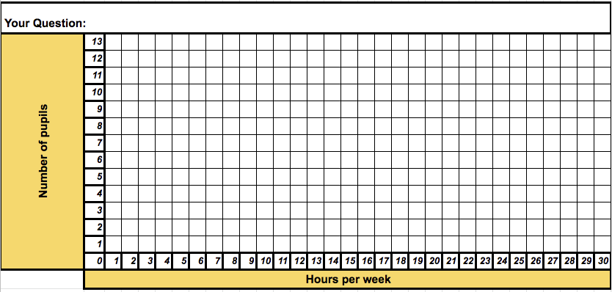

- Find the classmates with the same question. Share your results. Mark them down into the table.

- Present your results in your group.

- Feedback
It surprised me that ________________________________________________
It did not surprise me that __________________________________________
It is interesting that ________________________________________________

